Session 1 Date: 11/1/2024

Early 1990s established JAVA it follows WORA principle stands for write once, run anywhere.

Q1. Java is not a Pure OOPs. Why?

Ans.

The statement that "Java is not a pure OOPs (Object-Oriented Programming) language" might be rooted in the fact that Java supports some non-Object-Oriented features. However, Java is often considered to be a predominantly Object-Oriented language.

Here are a few reasons why some might argue that Java is not a "pure" OOP language:

Primitive Data Types: Java includes primitive data types (e.g., int, float, boolean) that are not objects. In a pure OOP language, everything would be treated as an object.

Multiple Inheritance: Java does not support multiple inheritance through classes (a class cannot extend more than one class). Some argue that this limits the expressive power of its OOP model.

Operator Overloading: not supported

Static Members: Java allows the use of static methods and variables, which are associated with the class rather than an instance of the class. In pure OOP languages, everything is typically an instance of a class.

Namespace: Java has a notion of a default namespace (package-level visibility), which is not strictly OOP. Pure OOP languages might not have this concept.

Q2. JAVA process

Ans.

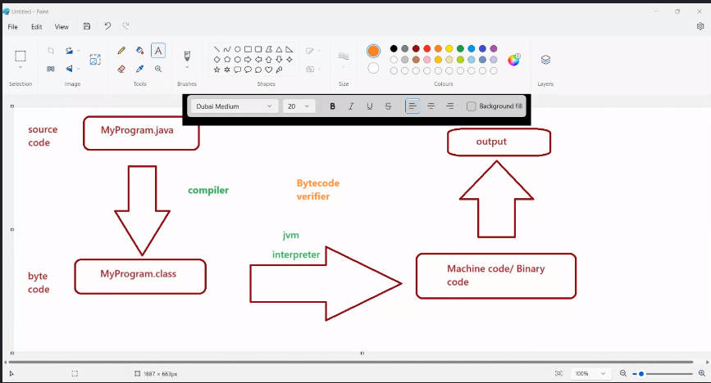

Q3. Features:

Ans.